**Hello Team!** **Consider the below two tables**:

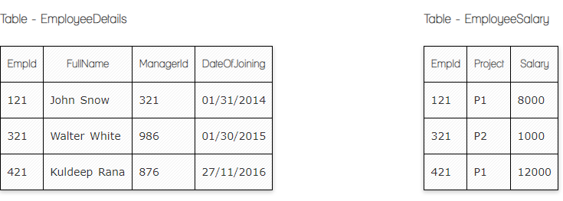

**Ques.1. Write a SQL query to fetch the count of employees working in project 'P1'.**

**Your Answer: Select count(Empid), project**

**From EmployeeSalary**

**Group by Project**

**~~Where~~ Having project=”P1”**

**Ques.2. Write a SQL query to fetch employee names having salary greater than or equal to 5000 and less than or equal 10000.**

**Your Answer: Select EmployeeDetails.FullName, EmployeeSalary.Salary**

**From EmployeeDetail**

**Full Join EmployeeSalary**

**ON employeedetails.empid=employeesalary.empid**

**Where Salary BETWEEN 5000 and 1000**

**Ques.3. Write a SQL query to fetch count of employees sorted by project's count in descending order.**

**Your Answer: Select count(emplid), project**

**From employeesalary  
 Group by project**

**Order by count(emplid)DESC**

**Ques.4. Write a query to fetch employee names and salary records. Return employee details even if the salary record is not present for the employee.**

**Your Answer: Select EmployeeDetails.FullName, EmployeeSalary.Salary**

**From EmployeeDetails**

**Left Join EmployeeSalary**

**ON employeedetails.empid=employeesalary.empid**

**Ques.5. Write a SQL query to create an empty table with ‘Test’ name.**

**Your Answer: Create table Test (**

**ID *null***

**Time *null***

**Price *null***

**Employee *null***

**Primary key (ID)**

**Ques.6. Write a SQL query to delete an empty table with ‘Test’ name.**

**Your Answer: Drop table Test**

**Ques.7. Write a SQL query to fetch all the Employees details from EmployeeDetails table who joined in Year 2016.**

**Your Answer: Select * From EmployeeDetails**

**Where DateofJoining** LIKE '2016%'

**Ques.8. Write a SQL query to insert new record to the EmployeeDetails table with any data.**

**Your Answer: Insert into EmployeeDetails (Empid, FullName, Managerid, Dateofjoining)**

**Values (“777”, “Gilbert Snowdan”, “435”, “27/05/2010”)**

**Ques.9. Write a SQL query to update EmployeeSalery table with setting Salary to 2000 for Project P2.**

**Your Answer: Update EmployeeSalary**

**Set salary=2000**

**Where Empid=321**

**Ques.10. Write a SQL query to right join both tables and draw the results.**

**Your Answer:**

|  |  |  |  |  |  |
| --- | --- | --- | --- | --- | --- |
| **Empid** | **FullName** | **Manageid** | **DateOfjoining** | **Project** | **Salary** |
| **121** | **John Snow** | **321** | **01/31/2014** | **P1** | **8000** |
| **321** | **Walter White** | **986** | **01/30/2015** | **P2** | **1000** |
| **421** | **Kuldeep Rana** | **876** | **27/11/2016** | **P1** | **12000** |

**Select EmployeeDetails.**

**From Employeesalary**

**Right Join Employeedetails**

**ON Employeedetails.Empid=Employeesalary.Empid**

**Now take these two tables:**

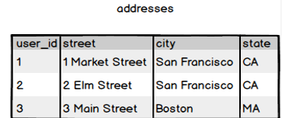

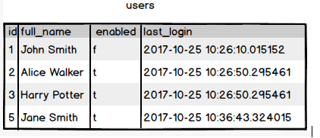

**Ques.11. Write a SQL query to fetch all users full_name from San Francisco.**

**Your Answer: Select users.full_name, addresses.city**

**From users**

**Inner join addresses**

**ON users.id=addresses.user_id**

**Ques.12. Write a SQL query to fetch all users full_name, last_login who are enabled**

**Your Answer: Select full_name, last login**

**From users**

**Where enabled=”t”**

**Ques.13. Write a SQL query to fetch all users full_name who are not from Main street**

**Your Answer: Select users.full_name, addresses.street**

**From users**

**Inner join addresses**

**ON users.id=addresses.user_id**

**Where not addresses.street = Main Street**

**Ques.14. Write a SQL query to fetch all users full_name who are from Main street or San Francisco**

**Your Answer: Select users.full_name, addresses.street, addresses.city**

**From users**

**Inner join addresses**

**ON users.id=addresses.user_id**

**Where addresses.street=Main street or addresses.city=San Francisco**

**Ques.15. Write a SQL query to fetch user full_name who is equal to user_id from Boston (find user_id value in sub_query)**

**Your Answer: Select full_name**

**From users**

**Where user_id=**

**(Select city**

**From addresses**

**Where city=”Boston”)**

**Good job ☺**